Colour Detection System: Build Instructions
Course: CENG 317
Student: Truong An Nguyen
Student ID: N01639800
Date: 8/19/2026
Table of Contents
1.0 Introduction
2.0 Added Functionality
2.1 Sensor/Effector Purchase
2.2 PCB Design and Soldering
2.3 Case Design and Assembly
2.4 Firmware Development and Use
3.0 Testing and Results
4.0 References
Appendix A: Wiring and Pin Assignments
Appendix B: Troubleshooting
Appendix C: Figures and Evidence
1.0 Introduction
This document provides detailed build instructions for a Raspberry Pi-based colour detection system. The target user is a Computer Engineering Technology student who has access to a Raspberry Pi 4 Model B Rev 1.5, a SparkFun Tristimulus Colour Sensor containing the OPT4048 high-speed, high-precision tristimulus XYZ sensor, a Raspberry Pi Sense HAT version 2.6.0, a standard LED, a custom PCB, and a 3D-printed enclosure.
The system measures colour and brightness, classifies the detected result as green, yellow, brown, or unknown, displays the classification on the Sense HAT LED matrix, and controls an external LED based on measured brightness. The Raspberry Pi communicates with the colour sensor through the Inter-Integrated Circuit (I2C) bus. The LED driver uses BCM GPIO 17, a 2.2 kΩ base resistor, a 2N4124 transistor, and a 220 Ω LED current-limiting resistor.
The instructions cover component selection, PCB design and soldering, enclosure assembly, Raspberry Pi configuration, software installation, firmware execution, calibration, testing, and troubleshooting. The colour thresholds are valid for the tested room-light environment and a target distance of approximately 5 cm. Thresholds must be recalibrated if lighting, sensor distance, target angle, or enclosure geometry changes.
The scope excludes manufacture of the Raspberry Pi, Sense HAT, and sensor modules. PCB fabrication and 3D printing were completed by the school; therefore, printer-model and print-setting details are not available. The KiCad design files, schematic, PCB layout, photographs, and test evidence should be attached as appendices.
2.0 Added Functionality
The completed system performs four coordinated tasks:
- The OPT4048 sensor is read through I2C.
- Red, green, blue, and brightness values are stored in shared program data.
- Threshold rules classify the measured condition.
- The Sense HAT displays the classification and the external LED responds to brightness.
The application uses four worker threads so that sensor acquisition, analysis, LED control, and display updates operate independently. A data lock protects the shared sensor dictionary. An I2C lock prevents overlapping access to the sensor bus. A stop event allows all worker threads to terminate when Ctrl+C is pressed.
GPIO 17 does not directly supply LED current. GPIO 17 drives the base of transistor Q1 through R1, a 2.2 kΩ resistor. Q1 switches the LED return path. R2, a 220 Ω resistor, limits current through the LED. This arrangement reduces the current handled directly by the Raspberry Pi GPIO pin.
2.1 Sensor/Effector Purchase
2.1.1 Bill of Materials
The following purchase information is based on the Group 8 DigiKey proof-of-payment record. The order subtotal was CAD $66.75, shipping was CAD $8.00, HST was CAD $9.72, and the total payment was CAD $84.47. The order was placed through DigiKey Electronics on May 26, 2026.
Item | DigiKey part number | Description | Quantity | Unit price CAD | Extended price CAD
1 | 1528-1783-ND | Stacking header for Raspberry Pi, part 1979 | 2 | 4.26 | 8.52
2 | 1597-1083-ND | Grove 2 mm, 4-pin right-angle connector, 10-pack | 2 | 2.46 | 4.92
3 | 1528-4528-ND | 4-pin STEMMA/Grove QT/Qwiic cable, 4 in | 2 | 2.82 | 5.64
4 | 1568-22726-ND | Flexible Qwiic cable, female | 2 | 2.87 | 5.74
5 | 145-50M025045I016-ND | M2.5 × 0.45 flat Phillips machine screw | 8 | 0.176 | 1.41
6 | 1528-5384-ND | STEMMA QT/Qwiic cable, 300 mm | 2 | 1.81 | 3.62
7 | 732-10422-ND | M2.5 × 0.45 steel hex standoff, 16 mm | 8 | 1.12 | 8.96
8 | 1568-22638-ND | SparkFun tristimulus colour sensor | 1 | 20.79 | 20.79

This was a shared Group purchase for four students. If the cost was divided equally, the estimated cost per member was CAD $14.13, calculated as CAD $56.53 divided by four ( this excludes the sensors). The total should be CAD $34.92 for this project only.
The supplied KiCad schematic also identifies a standard LED, R1 (2.2 kΩ), R2 (220 Ω), Q1 (2N4124 transistor), and PCB connectors. Add their purchase source and cost if they were purchased separately.
2.2 PCB Design and Soldering
2.2.1 PCB Specifications
The PCB was designed using KiCad. The board dimensions are 5.5 in wide × 3.5 in long × 1.5 in high. The 3.5 in measurement is the board length. The 1.5 in measurement is the height of the assembled PCB and components, not a PCB planar dimension. The PCB thickness is 0.2 in.
Note: A 0.2 in board thickness is unusually thick for a standard PCB. Before final submission, verify whether 0.2 in refers to the bare PCB thickness, the total assembly thickness, or another dimension shown on the mechanical drawing. Do not change the value unless it is confirmed from the drawing or fabrication record.
The PCB layout contains a Raspberry Pi 40-pin stacking header, I2C connector sections, LED driver components, and four mounting holes. The top copper layer is shown in red and the bottom copper layer is shown in blue in the KiCad layout.
2.2.2 Schematic Interpretation
The final KiCad schematic identifies the following functional connections:
- Physical pin 1 supplies 3.3 V.
- Physical pin 2 supplies 5 V where required by the associated connector or module.
- Physical pin 6 provides ground.
- Physical pin 3 provides GPIO2/SDA1 for I2C SDA.
- Physical pin 5 provides GPIO3/SCL1 for I2C SCL.
- Physical pin 11 provides GPIO17 for LED control.
- GPIO17 connects through R1, labelled 2.2 kΩ, to the base of Q1.
- Q1 is a 2N4124 transistor that switches the LED circuit.
- R2, labelled 220 Ω, is in series with the LED.
- Sensor connectors provide GND, VCC, SDA, and SCL.
Figure 2 and 3. Final KiCad schematic.
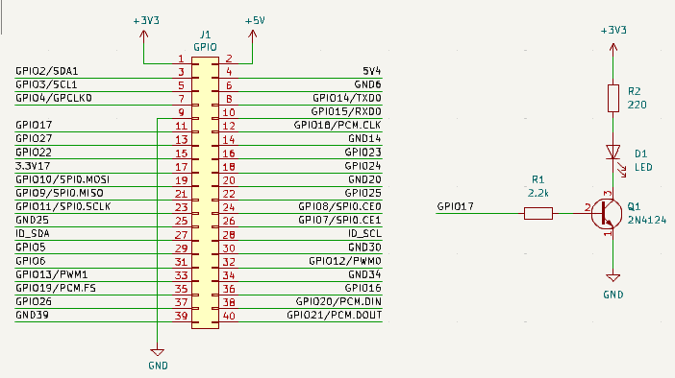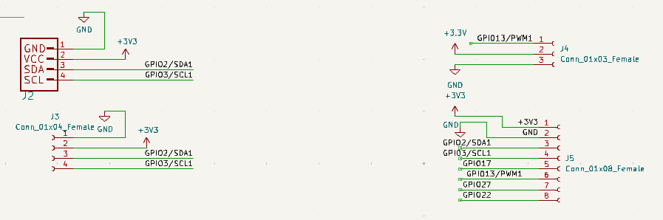

2.2.3 Connector Assignments
The connector functions are listed below. Pin numbering must be read from the connector orientation in the final KiCad schematic before making a physical connection.
Connector | Pin | Signal | Purpose
J4 | 1 | GPIO13/PWM1 | Auxiliary PWM/GPIO output
J4 | 2 | +3.3 V | 3.3 V supply
J4 | 3 | GND | Ground return
J5 | 1 | +3.3 V | 3.3 V supply
J5 | 2 | GND | Ground return
J5 | 3 | GPIO2/SDA1 | I2C data
J5 | 4 | GPIO3/SCL1 | I2C clock
J5 | 5 | GPIO17 | LED-driver control signal
J5 | 6 | GPIO13/PWM1 | Auxiliary PWM/GPIO output
J5 | 7 | GPIO27 | Auxiliary GPIO
J5 | 8 | GPIO22 | Auxiliary GPIO

J4 is a three-pin auxiliary connector. It provides a 3.3 V supply, ground, and GPIO13/PWM1. J5 is an eight-pin expansion connector. It exposes 3.3 V, ground, I2C SDA/SCL, GPIO17, GPIO13/PWM1, GPIO27, and GPIO22. J5 is useful for checking I2C signals, accessing the LED control signal, or connecting a future auxiliary device. It is not necessary to connect all J5 pins for the colour sensor to operate.
2.2.4 PCB Soldering Procedure
- Disconnect the Raspberry Pi power supply.
- Compare the unpopulated PCB with the final KiCad schematic.
- Inspect the board for damaged pads, shorts, contamination, or incorrect dimensions.
- Install low-profile components first.
- Install R1 and verify that it is 2.2 kΩ.
- Install R2 and verify that it is 220 Ω.
- Install Q1, the 2N4124 transistor, in the orientation shown by the KiCad footprint and schematic.
- Install the LED with the polarity shown in the schematic.
- Install the Raspberry Pi stacking header and I2C connectors.
- Solder one lead of each component, inspect alignment, and solder the remaining leads.
- Remove excess leads after inspecting each joint.
- Inspect every solder joint for bridges, cold joints, lifted pads, and insufficient solder.
- Use a multimeter in continuity mode to verify ground continuity and confirm that 3.3 V is not shorted to ground.
- Verify continuity from GPIO17 to R1, from R1 to Q1 base, and from the LED circuit to its return path.
- Verify continuity from the Raspberry Pi header to the I2C sensor connectors: SDA, SCL, 3.3 V, and GND.
- Connect the Raspberry Pi only after electrical inspection is complete.
Figure 4. KiCad PCB layout.
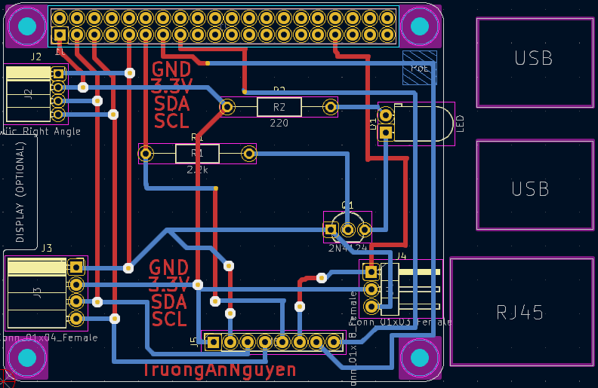
Figure 5. Soldered PCB, top side.
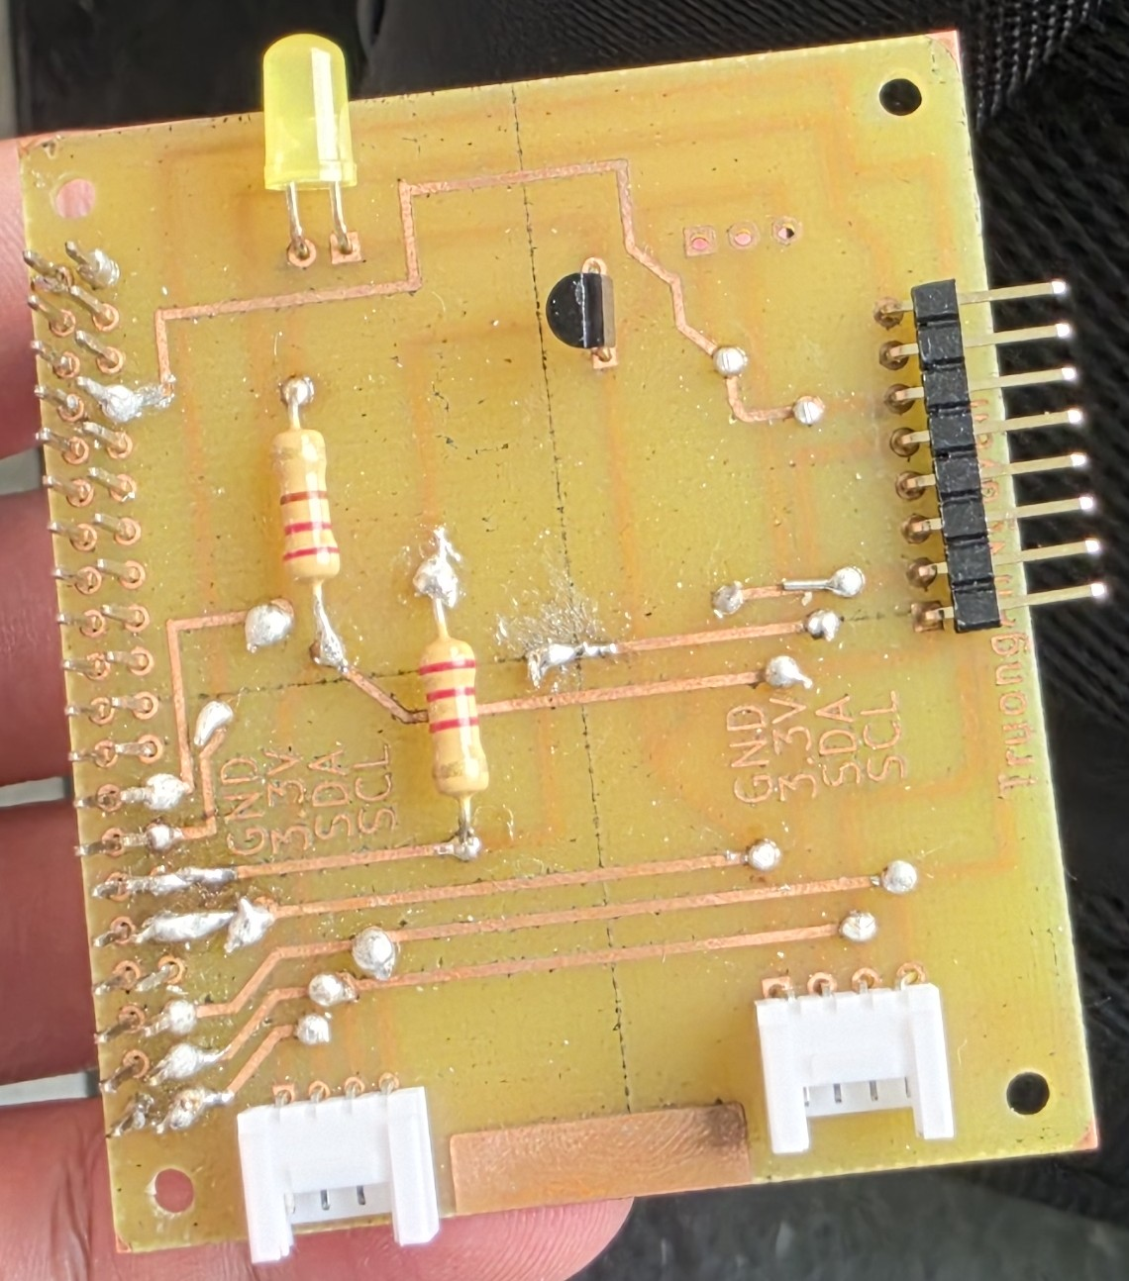
Figure 6. Soldered PCB, bottom side.
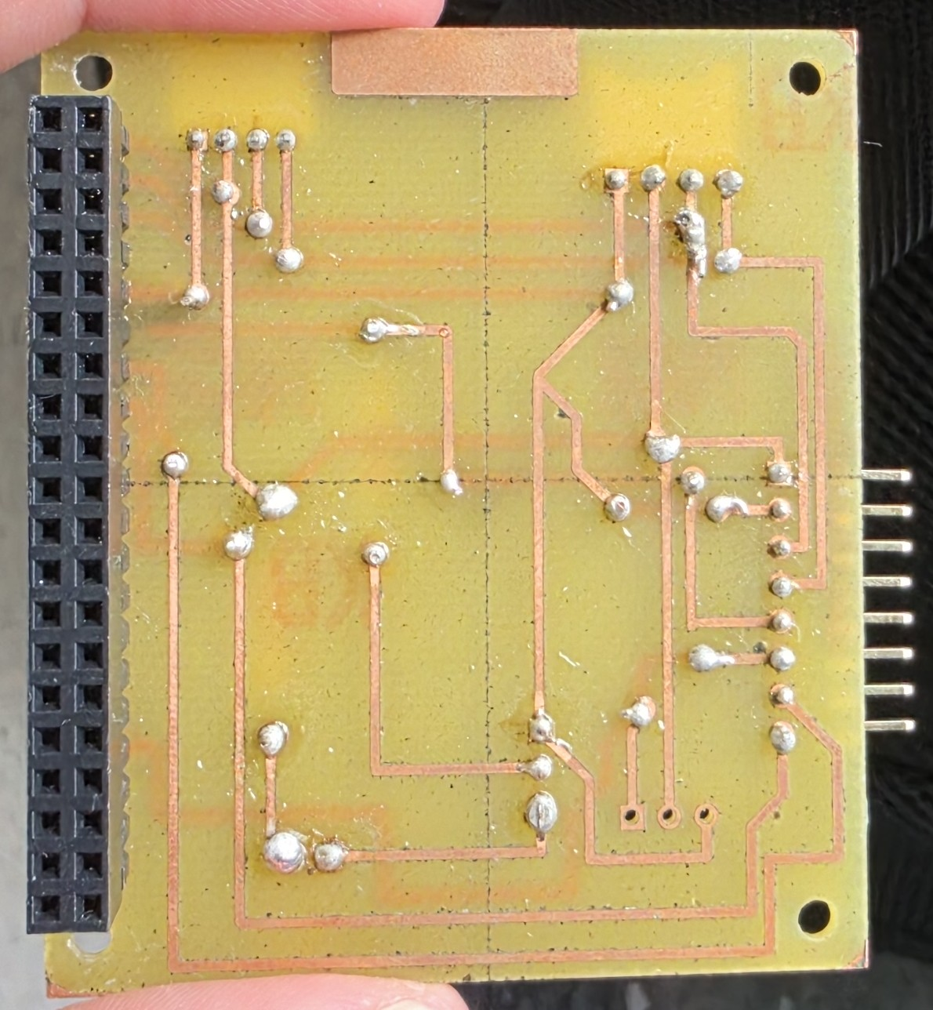
2.3 Case Design and Assembly
2.3.1 Enclosure Terms
The enclosure was 3D printed by the school. The printer model, filament material, layer height, and infill percentage were not provided. These manufacturing parameters are therefore not specified in this report.
2.3.2 Enclosure Assembly
- Inspect the printed parts for warping, blocked openings, sharp edges, and damaged mounting features.
- Place the Raspberry Pi and PCB in the enclosure without tape.
- Confirm that the Raspberry Pi header and PCB header are aligned.
- Align the colour sensor with its opening so that no opaque material blocks the sensor.
- Align the external LED with its intended opening or illumination direction.
- Route wires so that they do not strain sensor connectors or contact solder joints.
- Confirm that the Sense HAT remains correctly mounted on the Raspberry Pi header.
- Power the open assembly and complete electrical and software tests before closing the enclosure.
- Apply tape to secure components after testing is complete.
- Close the enclosure and verify that the sensor and LED remain aligned.
- Confirm that the power connection remains accessible.
Tape was used as a temporary prototype fastening method. A future revision should use screws, threaded inserts, clips, or snap-fit features for improved mechanical strength.
Figure 7. Completed enclosure.
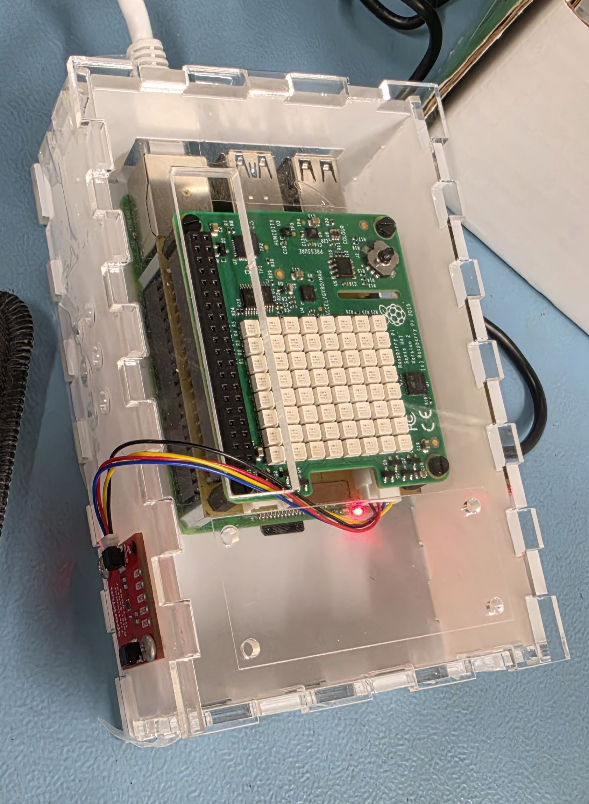
2.4 Firmware Development and Use
2.4.1 Raspberry Pi Configuration
- Start Raspberry Pi OS and open a terminal.
- Update the package list:
sudo apt update
- Install available operating-system updates:
sudo apt full-upgrade -y
- Enable I2C:
sudo raspi-config
Select Interface Options, select I2C, select Yes, and reboot if requested.
- Install I2C tools, Python virtual-environment support, and pip:
sudo apt install -y i2c-tools python3-pip python3-venv
- Confirm that the I2C device exists:
ls /dev/i2c-*
- Scan the I2C bus:
sudo i2cdetect -y 1
The OPT4048 sensor appears at I2C address 0x44. The project uses the SparkFun Tristimulus Colour Sensor, DigiKey part number 1568-22638-ND, which contains the OPT4048 sensor device. If 44 does not appear in the scan table, disconnect power and inspect the 3.3 V, ground, SDA, and SCL connections before continuing.
2.4.2 Python Environment and Libraries
Create a project directory and Python virtual environment:
mkdir -p ~/Hardware_Productions/color_detection
cd ~/Hardware_Productions/color_detection
python3 -m venv .venv --system-site-packages
source .venv/bin/activate
Install the OPT4048 CircuitPython library:
python -m pip install --upgrade pip
python -m pip install adafruit-circuitpython-opt4048
The commands above install software used by the project. python3-venv creates an isolated Python environment. pip installs Python libraries. adafruit-circuitpython-opt4048 supplies the Python driver for the colour sensor.
Test the Sense HAT and GPIO libraries:
python -c "from sense_hat import SenseHat; print('Sense HAT library available')"
python -c "import RPi.GPIO as GPIO; print('RPi.GPIO library available')"
Save the final program as test_sensor_fixed.py in the project directory.
2.4.3 Firmware Operation
The program initializes GPIO17, I2C, the OPT4048, the Sense HAT, shared data, locks, and a stop event. Four worker threads then perform sensor acquisition, colour classification, LED control, and display updates.
The classification logic evaluates conditions in the following order:
Priority | Rule | Result
1 | Brightness < 5 | UNKNOWN
2 | Green < 140 and blue < 50 | BROWN
3 | Brightness > 50 and blue < 10 | YELLOW
4 | Green ≥ 160 | GREEN
5 | No previous rule matches | UNKNOWN

The LED-control thread compares brightness with a threshold of 300. When brightness is below 300, the LED state alternates every 0.5 seconds, producing a blinking output. When brightness is 300 or greater, the LED is turned off and the blink state is reset.
2.4.4 Running the Program
- Open a terminal.
- Change to the project directory:
cd ~/Hardware_Productions/color_detection
- Activate the virtual environment:
source .venv/bin/activate
- Run the firmware:
python3 test_sensor_fixed.py
- Observe the terminal output for red, green, blue, brightness, and colour condition.
- Observe the Sense HAT display and external LED.
- Stop the program safely by pressing Ctrl+C once.
- Confirm that the LED turns off, the Sense HAT is cleared, and the terminal returns to the command prompt.
Figure 8. Raspberry Pi terminal output.
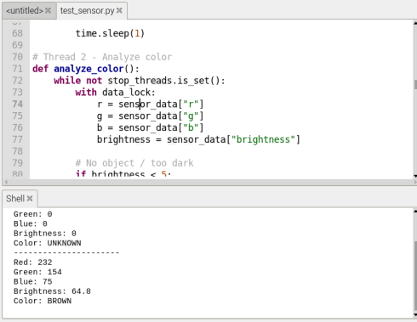
Figure 9. I2C scan.
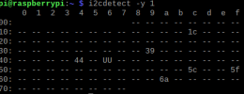
Figure 10. Firmware flowchart.
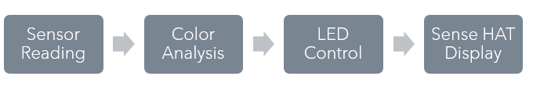
2.4.5 Error Handling and Shutdown
The sensor-reading thread catches OSError and RuntimeError, including I2C and OPT4048 CRC failures. After an error, the condition becomes UNKNOWN, the program waits, and the sensor measurement mode is restarted.
When Ctrl+C is pressed, the main thread sets the stop event. The worker threads exit their loops. The program then turns off GPIO17, clears the Sense HAT, and calls GPIO.cleanup(). This procedure prevents the LED-control thread from switching the LED back on during shutdown.
3.0 Testing and Results
3.0.1 Test Conditions
Testing was completed in a room-light environment with a measured brightness of approximately 200. Each coloured object was positioned approximately 5 cm from the sensor. Under these test conditions, the system produced the expected colour classifications and outputs.
The distance, room-light level, object angle, and enclosure position should remain approximately constant when repeating the test. Changing any of these conditions may require recalibration of the colour thresholds.
3.0.2 Calibration Data
Target | Red | Green | Blue | Brightness | Classification observed | Result
Brown | 233 | 155 | 73 | 83 | BROWN | Pass
Green | 224 | 160 | 74 | 77 | GREEN | Pass
Yellow | 233 | 160 | 62 | 88 | YELLOW | Pass

The classifications above were reported as successful in the room-light environment at approximately 5 cm. The raw measurements overlap between samples, so the selected threshold method is specific to the implemented firmware and tested geometry. Additional readings should be collected if the implementation is moved to a different environment.
3.0.3 Functional Test Table
Test | Input condition | Expected result | Actual result | Pass/fail
1 | Brown target approximately 5 cm from sensor | Brown classification and brown Sense HAT display | Brown displayed correctly | Pass
2 | Green target approximately 5 cm from sensor | Green classification and green Sense HAT display | Green displayed correctly | Pass
3 | Yellow target approximately 5 cm from sensor | Yellow classification and yellow Sense HAT display | Yellow displayed correctly | Pass
4 | Low brightness | External LED blinks | LED blinks below brightness threshold | Pass
5 | Bright room-light environment, approximately brightness 200 | External LED turns off | LED turns off when brightness is sufficient | Pass
6 | Ctrl+C pressed | Threads stop, LED turns off, GPIO is cleaned up | Program shuts down correctly | Pass
7 | Temporary I2C/CRC failure | Error is caught and sensor reading retries | Error handling added to firmware | Pass

Figure 11. Brown-target test. Insert a photograph or screenshot showing the object, sensor, and output.
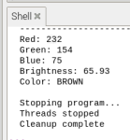
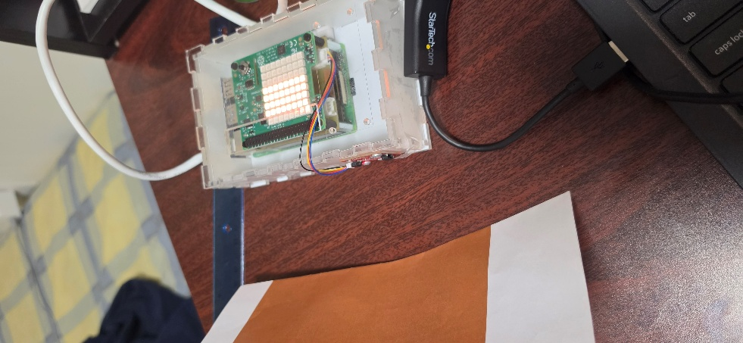
Figure 12. Green-target test. Insert a photograph or screenshot showing the object, sensor, and output.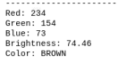
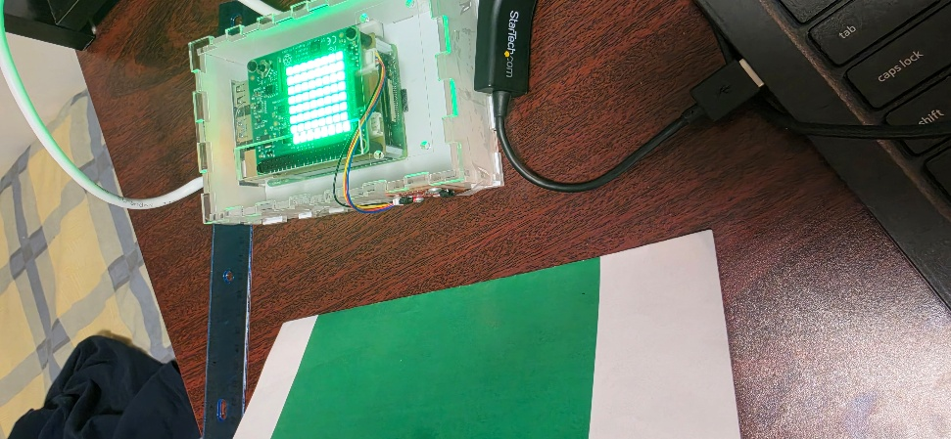
Figure 13. Yellow-target test. Insert a photograph or screenshot showing the object, sensor, and output. 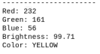
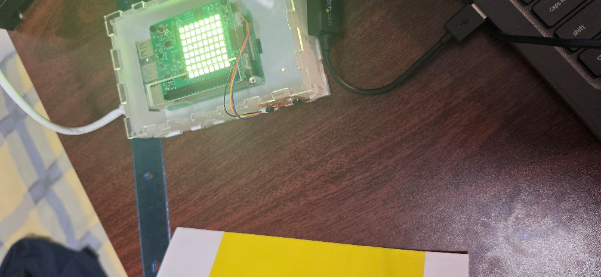
Figure 14. Ctrl+C shutdown test. Insert a screenshot showing cleanup messages.
3.0.4 Problems and Resolutions
I2C communication errors
I2C errors can result from incorrect SDA/SCL wiring, unstable power, electrical noise, long wires, or a disabled I2C interface. The bus is checked with i2cdetect, connections are inspected against the KiCad schematic, and the sensor is restarted after a failed read.
Unstable sensor readings
Unstable readings can result from changing ambient light, target movement, sensor distance, reflections, and sensor settling time. Testing uses a target distance of approximately 5 cm and consistent room lighting. Repeated readings and fixed geometry reduce variation.
Multithreading synchronization
The four threads share sensor readings and condition data. Without locks, one thread could read values while another thread updates them. data_lock protects the shared dictionary, while i2c_lock prevents conflicting sensor-bus operations. The stop event prevents worker threads from continuing during shutdown.
Colour-threshold selection
Colour thresholds were determined through testing with known brown, green, and yellow targets in the room-light environment. The thresholds must be recalibrated if lighting, target distance, target material, or enclosure geometry changes.
3.0.5 Conclusion
The completed build provides a Raspberry Pi colour-detection prototype using an OPT4048 sensor, a custom KiCad PCB, a transistor-switched LED, a Sense HAT display, and a 3D-printed enclosure. The PCB provides I2C sensor connections and a GPIO17 LED driver circuit. The Python application separates acquisition, analysis, actuation, and display tasks through synchronized threads.
Under room lighting with brightness of approximately 200 and a target distance of approximately 5 cm, the system successfully identified brown, green, and yellow test objects. The external LED responded to the brightness threshold, and the shutdown procedure turned off the LED and cleared the Sense HAT after Ctrl+C.
3.0.6 Recommendations
- Add a calibration mode that records reference readings for known targets.
- Average several readings before classification to reduce short-term variation.
- Store readings in a CSV file for quantitative threshold analysis.
- Replace tape with screws, threaded inserts, clips, or snap-fit features.
- Add a clearly labelled service connector for I2C and power measurements.
- Add a controlled sensor-reset procedure for persistent I2C errors.
4.0 References
- Raspberry Pi Foundation. Raspberry Pi 4 Model B documentation.
- Texas Instruments. OPT4048 High-Speed High-Precision Tristimulus XYZ Colour Sensor Datasheet.
- Adafruit Industries. Adafruit CircuitPython OPT4048 Library Documentation.
- Raspberry Pi Foundation. Sense HAT Python Documentation.
- Python Software Foundation. Python Threading Documentation.
- RPi.GPIO maintainers. RPi.GPIO Documentation.
- DigiKey Electronics. Group 8 Proof of Payment, Web ID 372210238. Submitted May 26, 2026.
- OACETT. Technology Report Guidelines. Revised June 2022.
- KiCad. KiCad Documentation.
Appendix A: Wiring and Pin Assignments
Signal | Raspberry Pi physical pin | BCM/signal name | Destination | Function
3.3 V | 1 | 3V3 | Sensor VCC, J4 pin 2, J5 pin 1 | Sensor/auxiliary supply
5 V | 2 | 5V | J1 as shown in schematic | Auxiliary/module supply; verify module requirement
Ground | 6 | GND | Sensor ground, J4 pin 3, J5 pin 2, LED-driver return | Common return
SDA | 3 | GPIO2/SDA1 | Sensor SDA, J5 pin 3 | I2C data
SCL | 5 | GPIO3/SCL1 | Sensor SCL, J5 pin 4 | I2C clock
LED control | 11 | GPIO17 | R1 then Q1 base; J5 pin 5 | LED-driver control
Auxiliary PWM | [Verify from 40-pin header] | GPIO13/PWM1 | J4 pin 1 and J5 pin 6 | Auxiliary PWM/GPIO
Auxiliary GPIO | [Verify from 40-pin header] | GPIO27 | J5 pin 7 | Auxiliary GPIO
Auxiliary GPIO | [Verify from 40-pin header] | GPIO22 | J5 pin 8 | Auxiliary GPIO

The OPT4048 appears at I2C address 0x44 during the bus scan. The final report should include an enlarged schematic and a photograph of the actual connector wiring.
Figure 20. Final labelled wiring diagram. Insert an enlarged version of the schematic with connector orientation, pin numbering, and physical Raspberry Pi pin numbers readable.
Appendix B: Troubleshooting
Symptom | Likely cause | Corrective action
No 44 address in i2cdetect | I2C disabled, incorrect wiring, no power, or loose connector | Enable I2C; inspect 3.3 V, GND, SDA, and SCL; rescan
CRC check failed | Corrupted I2C data, unstable power, electrical noise, or sensor state error | Inspect wiring/power, reduce wire length/noise, retry, and restart sensor mode
LED remains on after Ctrl+C | Worker thread continues or driver circuit differs from expected polarity | Use stop event, wait for threads, set GPIO17 low, then verify Q1 and LED orientation
Sense HAT remains lit | Display was not cleared | Confirm shutdown calls sense.clear()
Incorrect colour classification | Lighting, distance, or thresholds differ from calibration | Restore approximately 5 cm distance and room lighting, or recalibrate
GPIO warning | Previous process did not clean up the pin | Stop old processes, call GPIO.cleanup(), and enable warnings while debugging
Sensor values fluctuate | Target movement, reflections, changing illumination, or insufficient averaging | Fix target position and lighting, then average repeated readings

Appendix C: Figures and Evidence
Figure 1: Components before assembly.
Figure 2: Final KiCad schematic.
Figure 3: KiCad PCB layout.
Figure 4: Soldered PCB, top side.
Figure 5: Soldered PCB, bottom side.
Figure 6: Completed enclosure.
Figure 7: Raspberry Pi terminal output.
Figure 8: I2C scan showing address 0x44.
Figure 9: Firmware flowchart.
Figure 10: Brown-target test.
Figure 11: Green-target test.
Figure 12: Yellow-target test.
Figure 13: Ctrl+C shutdown test.
Appendix D: Complete Firmware source code
import board
import busio
import adafruit_opt4048
import time
import threading
import RPi.GPIO as GPIO
from sense_hat import SenseHat

# LED setup
LED_PIN = 17

GPIO.setwarnings(False)
GPIO.setmode(GPIO.BCM)
GPIO.setup(LED_PIN, GPIO.OUT)
GPIO.output(LED_PIN, GPIO.LOW)

# OPT4048 Setup
i2c = busio.I2C(board.SCL, board.SDA)
sensor = adafruit_opt4048.OPT4048(i2c)
sensor.mode = 3

time.sleep(1)

sensor_data = {
"r": 0,
"g": 0,
"b": 0,
"brightness": 0,
"condition": "UNKNOWN"
}

# Sense HAT Setup
sense = SenseHat()
sense.clear()

# Protect shared variables
data_lock = threading.Lock()

# Protect I2C communication
i2c_lock = threading.Lock()

# Stop signal for graceful shutdown
stop_threads = threading.Event()

# Thread 1 - Read sensor
def read_sensor():
while not stop_threads.is_set():
try:
# Only one thread can access I2C
with i2c_lock:
r, g, b, brightness = sensor.rgb
with data_lock:
sensor_data["r"] = r
sensor_data["g"] = g
sensor_data["b"] = b
sensor_data["brightness"] = brightness
except (OSError, RuntimeError) as e:
print("I2C Error:", e)
# Mark sensor as invalid
with data_lock:
sensor_data["condition"] = "UNKNOWN"

time.sleep(2)
# Restart measurement
with i2c_lock:
sensor.mode = 3

time.sleep(1)

# Thread 2 - Analyze color
def analyze_color():
while not stop_threads.is_set():
with data_lock:
r = sensor_data["r"]
g = sensor_data["g"]
b = sensor_data["b"]
brightness = sensor_data["brightness"]

# No object / too dark
if brightness < 5:
condition = "UNKNOWN"
else:
# Calculate differences
r_minus_g = r - g
g_minus_b = g - b

# Yellow: Highest G-B difference (blue is very low)
if g_minus_b > 95:
condition = "YELLOW"
# Brown: High R-G difference (red much higher than green)
elif r_minus_g > 75:
condition = "BROWN"
# Green: Lower R-G difference, moderate G-B difference
elif r_minus_g < 65 and g_minus_b > 80:
condition = "GREEN"
else:
condition = "UNKNOWN"

with data_lock:
sensor_data["condition"] = condition
time.sleep(1)

# Thread 3 - Control LED
def control_led():
blink_state = False

while not stop_threads.is_set():
with data_lock:
brightness = sensor_data["brightness"]

if brightness < 300:
blink_state = not blink_state
GPIO.output(LED_PIN, GPIO.HIGH if blink_state else GPIO.LOW)
time.sleep(0.5)
else:
GPIO.output(LED_PIN, GPIO.LOW)
blink_state = False
time.sleep(0.5)

# Thread 4 - Display color
def display_color():
while not stop_threads.is_set():
with data_lock:
color = sensor_data["condition"]
if color == "GREEN":
sense.clear(0, 255, 0)
elif color == "YELLOW":
sense.clear(255, 255, 0)
elif color == "BROWN":
sense.clear(120, 70, 20)
elif color == "UNKNOWN":
sense.clear(0, 0, 0)
time.sleep(1)

# Start Threads
sensor_thread = threading.Thread(
target=read_sensor,
daemon=True
)

analysis_thread = threading.Thread(
target=analyze_color,
daemon=True
)

led_thread = threading.Thread(
target=control_led,
daemon=True
)

display_thread = threading.Thread(
target=display_color,
daemon=True
)

sensor_thread.start()
analysis_thread.start()
led_thread.start()
display_thread.start()

# Main Program Display
try:
while not stop_threads.is_set():
with data_lock:
print("----------------------")
print("Red:", round(sensor_data["r"]))
print("Green:", round(sensor_data["g"]))
print("Blue:", round(sensor_data["b"]))
print("Brightness:", round(sensor_data["brightness"], 2))
print("Color:", sensor_data["condition"])

time.sleep(1)

except KeyboardInterrupt:
print("\nStopping program...")
stop_threads.set()
time.sleep(0.5)

print("Threads stopped")
GPIO.output(LED_PIN, GPIO.LOW)
sense.clear()
GPIO.cleanup()
print("Cleanup complete")

